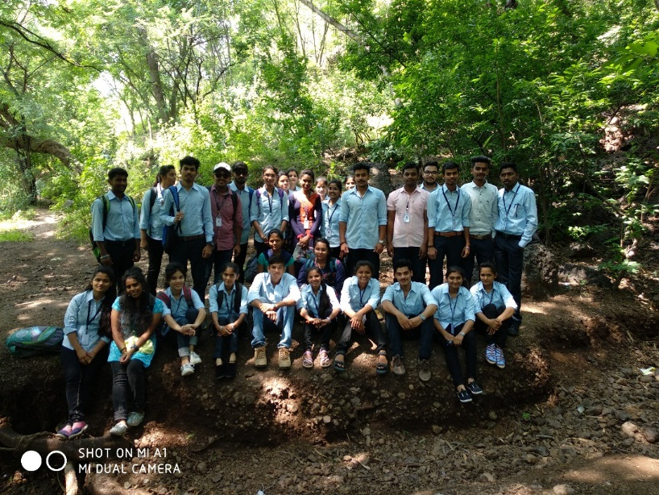
Dongargan,Ahmednagar (September 2018)

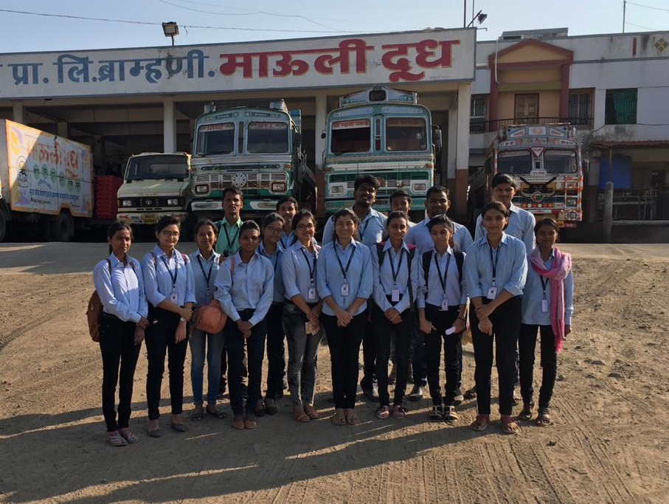
Mauli Dudh Dairy visit (October 2018)

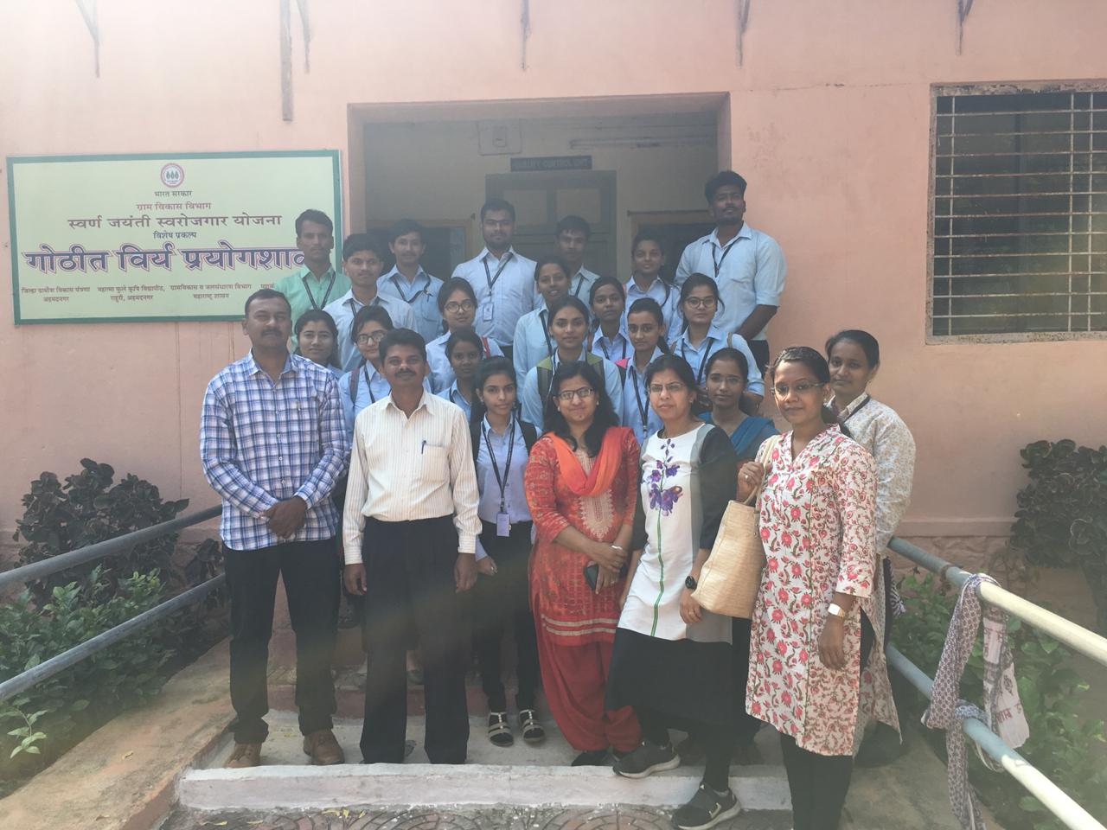
Semen laboratory visit, Rahuri (October 2018)

Sr.No | Scientist Name | Designation | Institute | Topic of lecture
1 | Mr Priyank Nimje | Associate professor | South Eastern University, Norway | Population Genetics
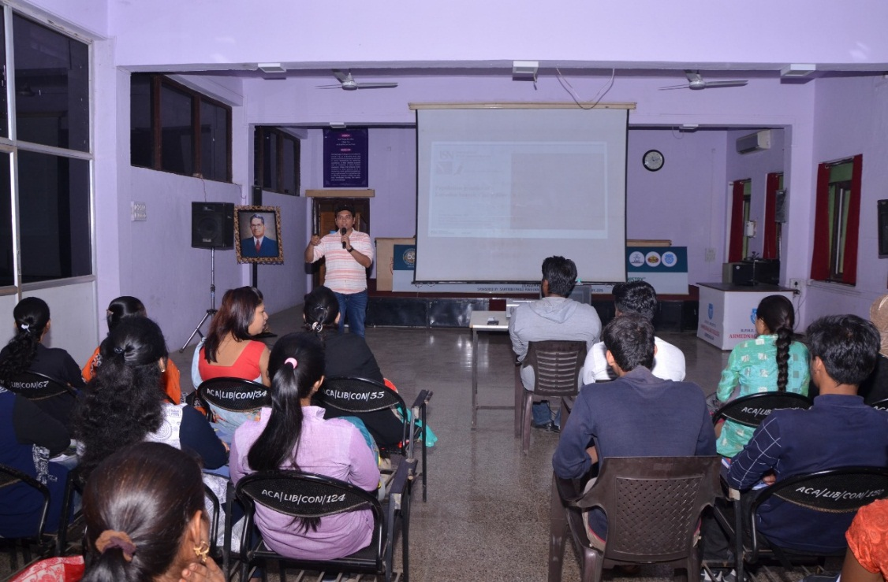

Name of Conference/ Seminars / Workshops | Funding agency | No. of  Participants | University/State/National/  International | Dates
Seminar | College | 112 | College | 15/02/2019
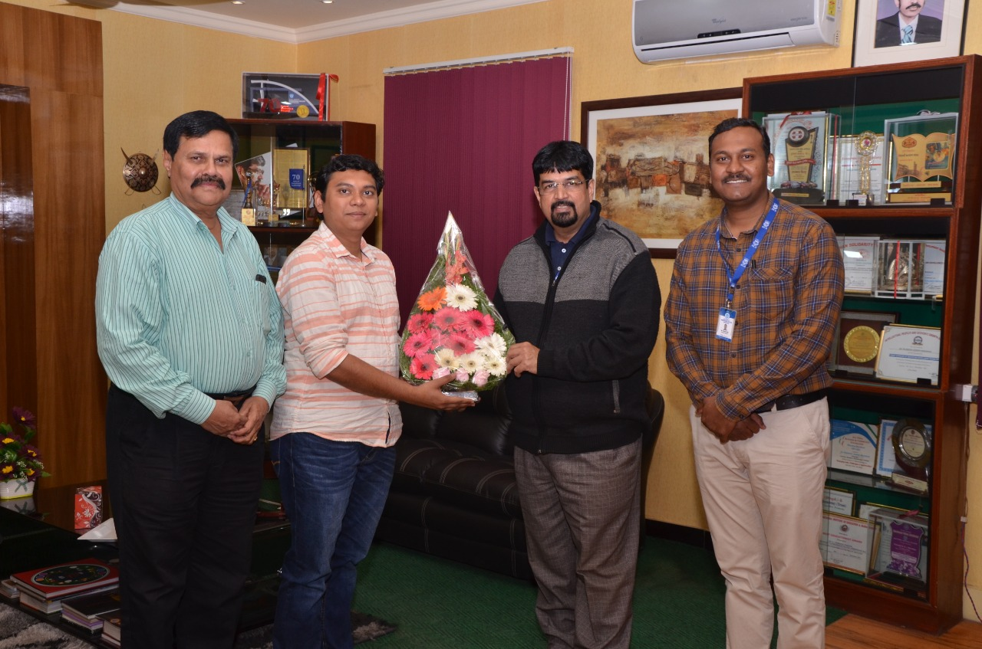

Guest lecture by Dr. Priyank Nimje, Associate professor, South Eastern University, Norway

